Boerne ISD
Dual Credit
2023-2024

Dual Credit Application Deadlines

November/December Apply Texas Application

February 15, 2024 Apply Texas Application Deadline
April 12, 2024 Deadline to complete ACES modules,
Dual Credit Student Orientation,
and/or TSI Prep at: https://practice.accuplacer.org/login
Ongoing TSI Assessment
February Pick dual credit classes during course selection
May 17, 2024 Deadline for Northwest Vista College to receive initial ACT, SAT,
or TSI test results

Frequently Asked Questions
1. What is Dual Credit?
Dual Credit is a coordinated program between Boerne ISD and higher education partners that allows students to earn college and high school credit for courses successfully completed at the high school campus.
2. How do I qualify for dual credit?
In order to qualify and enroll in dual credit courses, students must complete all enrollment steps set forth by Northwest Vista College.
3. How is Dual Credit different from Advanced Placement (AP)?
Advanced Placement courses are rigorous college level courses that follow curriculum approved by the College Board. Students scoring a 3, 4, or 5 on one or more of these tests may be awarded credit by the college in which they enroll after high school. Dual Credit is also rigorous; however, students are awarded college credit upon successful completion of the course(s). Students should consult specific colleges/university websites to verify Dual Credit and accepted AP tests and scores and how they will fit into a potential degree plan.
4. How many Dual Credit courses can I take?
High school students can take unlimited dual credit courses while in high school that aligns with the students pathway and graduation plan.
5. What is Alamo Colleges Education Services (ACES)?

ACES is a secure Alamo Colleges/Northwest Vista College portal connecting students to academic resources, course registration information, transcript services, library resources, and access to complete required enrollment steps such as Go FAAR, Test prep, and Dual Credit Student Orientation.
6. How do I know that a grade from Boerne ISD matches the grade recorded at NVC?
Students can log in to ACES to check their college email to see grades that have been posted for dual credit courses. Colleges post the following letter grades:
A: 90-100, B: 80-89, C: 70-79, D: 65-69, F: below a 65

7. How do I earn credit for dual credit courses?
To earn both high school and college credit, students must successfully complete the dual credit course with a grade of 70 or higher.
8. How do I know what credit I will receive at the college I attend after high school?
Your dual credit courses will be applied to both your high school and college transcripts. You have access to your course registration and your college transcript through ACES. Refer to the Texas Common Course Numbering System at www.tccns.org , www.transferology.com, as well as the Alamo College Transfer Guides to determine what credit a two- or four-year institution will award you once you transfer your credits.
9. How does dual credit affect my college transcript?
3-Peat Rule: If you attempt the same course three times, you will pay out of state tuition for the third attempt. This includes all attempts, including failed courses and withdrawals, including dual credit.
6 Drop Rule: You cannot withdraw (after Census) from more than 6 college courses, including dual credit. An attempt to withdraw from a 7th course will be denied by the college.
Failing grades or withdrawals (after Census) from dual credit count against Satisfactory Academic Progress (SAP). Failure to demonstrate SAP may affect eligibility for future financial aid.
10. How do my grades transfer from dual credit/dual enrollment college partners to another institution?
After graduation, students must request an official transcript from the college to the college/university the student will be attending. Transcript requests can be made through the student college account.
11. Will dual credit affect my status at a college or university?
The dual credit transcript must be sent to the college or university the student attends after high school graduation. If a student earns 30 or more hours, the student may be classified as a sophomore or higher. This could affect financial aid and scholarships, but many schools will consider the student as a “first-time student” for freshman scholarships. Please contact the admissions and financial aid offices of individual colleges and universities for the policy.
12. How much does it cost to take Dual Credit courses?
Dual credit tuition and books are free to Boerne ISD students enrolled in Alamo Colleges courses, however, there is a fee for college readiness testing. Students enrolled in Angelo State, UT OnRamps and Tarleton Today courses will incur tuition no greater than $50 per credit hour. Check with your school counselor regarding college readiness testing.
13. What courses should I take?
Consider looking at degree programs at potential colleges/universities and compare required courses with BISD dual credit courses. You can compare courses using www.tccns.org and www.transferology.com to decide which courses will best fit into your plan.
14. Do I need to reapply for Dual Credit every year?
A student will need to reapply the following year if he or she does not qualify for dual credit. In addition, if a student qualifies for dual credit but does not enroll in any dual credit courses, the student will need to reapply the following year.

Alamo College Dual Credit Course Offerings and Credit
High School Course | College Course | Prerequisite | High School  Credit Earned | College  Credit Earned
1404 Dual English 4 (Comp) | ENGL 1301/1302  Composition 1/2 |  | 1 | 6 hours  (3 per semester)
1414 AP/Dual English 4 (Lit) | ENGL 2332/2333  World Lit 1/2 | 3 or higher on AP Language Exam | 1 | 6 hours  (3 per semester)
2604 College Algebra | MATH 1414  College Algebra Pre-cal Track |  | 1 | 4 hours
2403 PreAP/Dual Pre-calculus | MATH 1414/ 2412  College Algebra/Pre-calculus |  | 1 | 8 hours  (4 per semester)
2515 AP/Dual Calculus AB | MATH 2413  Calculus 1 | MATH 1414/2412  PreAP/Dual Pre-calc | 1 | 4 hours
2516 AP/Dual Statistics | MATH 1442  Elementary Statistical Methods |  | 1 | 4 hours
3104 AP/Dual Biology | BIOL 1406/ 1407  Biology for Science Majors 1 and 2 with labs |  | 1 | 8 hours  (4 per semester)
3203 AP/Dual Chemistry | CHEM 1311/1312 | *see below | 1 | 8 hours  (4 per semester)
4304 AP/Dual US Government | GOVT 2305  Federal Government |  | .5 | 3 hours
1644 Dual Spanish 4 | SPAN 2311/2312  Intermediate Spanish 1/2 | Credit in Spanish 1,2, & 3 at high school | 1 | 6 hours  (3 per semester)
5640 Dual Accounting 1 | ACCT 2301  Financial Accounting for Business Majors | Credit in Prin. of Bus, Mktg, Fin. at high school | 1 | 3 hours
5646 Dual Medical Terminology | HITT 1305  Medical Terminology | Credit in  Princ. of Health Science at high school | 1 | 3 hours
Dual US History | HIST 1301/ 1302 |  | 1 | 6 hours
Dual Theatre Arts | DRAM 1310 | teacher approval | 1 | 3 hours
*The prerequisite for dual chemistry is: credit for or concurrently enrolled in one of the following classes: dual credit college algebra, honors pre-cal, dual pre- cal, AP/Dual Statistics, or AP/Dual Calculus.
Dual Credit courses are subject to instructor availability and enrollment.

Students may take up to 14 dual credit courses while in high school and up to 4 courses per semester.
Students should send AP Language scores of 3+ to Northwest Vista College and submit a request in the NVC
registrar’s office to place AP scores on the NVC college transcript to earn credit for English 1301 and 1302.

Dual Credit Testing Requirements
In order to enroll in dual credit, students must have a qualifying Texas Success Initiative (TSI) Assessment score or an ACT or SAT score that exempts the student from the TSI. The TSI assessment is given at the high school campus. Students wishing to use the ACT or SAT exemption are responsible for sending an official score report to Northwest Vista College by the stated deadline.
High School/ College Course | TSI Math | TSI ELAR | TSI Writing & Essay | ACT | SAT
1404 Dual English 4 | Must be attempted | 945 | Essay 5 | 23 Comp. w/ 19 on Eng & Math | 480 on EBRW & 530 on Math
1414 AP/Dual English 4  *must score a 3+ on Eng 3 AP exam | Must be attempted | 945 | Essay 5 | 23 Comp. w/ 19 on Eng & Math | 480 on EBRW & 530 on Math
2604 College Algebra | 950 | 945 | Essay 5 | 23 Comp. w/ 19 on Eng & Math | 480 on EBRW & 530 on Math
2403 Pre-AP/Dual Pre-calculus | 950 | Must be attempted | Must be attempted | 23 Comp. w/ 19 on Eng & Math | 480 on EBRW & 530 on Math
2413 Dual/AP Calculus AB | 950 | 945 | Essay 5 | 23 Comp. w/ 19 on Eng & Math | 480 on EBRW & 530 on Math
1442 Dual/ AP Statistics | 950 | Must be attempted | Must be attempted | 23 Comp. w/ 19 on Eng & Math | 480 on EBRW & 530 on Math
3104 AP/Dual Biology | 950 | 945 | Essay 5 | 23 Comp. w/ 19 on Eng & Math | 480 on EBRW & 530 on Math
3203 AP/Dual Chemistry | 950 | 945 | Essay 5 | 23 Comp. w/ 19 on Eng & Math | 480 on EBRW & 530 on Math
4304 AP/Dual US Government | Must be attempted | 945 | Essay 5 | 23 Comp. w/ 19 on Eng & Math | 480 on EBRW & 530 on Math
1644 Dual Spanish 4 | Must be attempted | Must be attempted | Must be attempted | 23 Comp. w/ 19 on Eng & Math | 480 on EBRW & 530 on Math
Dual Accounting 1 | 950 | 945 | Essay 5 | 23 Comp. w/ 19 on Eng & Math | 480 on EBRW & 530 on Math
Dual Medical Terminology | Must be attempted | 945 | Essay 5 | 23 Comp. w/ 19 on Eng & Math | 480 on EBRW & 530 on Math
Dual US History | Must be attempted | 945 | Essay 5 | 23 Comp. w/ 19 on Eng & Math | 480 on EBRW & 530 on Math
Dual Theatre Arts | Teacher approval | Teacher approval | Teacher approval | Teacher approval | Teacher approval
Score requirements are subject to change per Northwest Vista College
- Math: A College Readiness Classification (CRC) score below 950 and a diagnostic level of 6 is considered passing
- ELAR: CRC score below 945 and a diagnostic level of 5 or 6 and an essay score of at least 5 is considered passing
- TSI Brochure
https://accuplacer.collegeboard.org/sites/default/files/accuplacer-tsi-assessment-student-brochure-v2.pdf
- The College Board-TSI Web-Based Study App- Texas Version https://store.collegeboard.org/sto/productdetail.do?Itemkey=130095469
- TSI Sample Questions
https://secure-media.collegeboard.org/digitalServices/pdf/accuplacer/accuplacer-texas-success-initiative-assessment-sample-questions.pdf

Northwest Vista Dual Credit Checklist

NEW Dual Credit Student Checklist

- Complete Apply Texas Application --students complete with parent support in December
  - Do not use student BISD email address; use a student personal email address
- Login to ACES Account--student completes this step
- Complete Go FAAR and Test Prep modules in ACES under “Start Here” tab
- Complete Dual Credit Student Orientation (DCSO) Online Course in ACES
- Submit Parent/Student Consent form with all signatures
- Earn College Readiness through ACT, SAT, or TSI
- Select Dual Credit courses with your counselor during course selection
- Check Dual Credit course registration in ACES at high school Schedule Pick UP/Prep Days in August

RETURNING Dual Credit Student Checklist
- Complete Apply Texas Application --students complete with parent support in December if you did not take a dual credit course this school year
  - Do not use student BISD email address; use a student personal email address
- Submit any retest scores before deadlines if necessary based on college readiness requirements
- Select Dual Credit courses with your counselor during course selection
- Check Dual Credit course registration in ACES at high school Schedule Pick UP/Prep Days in August

**Note: Students who do not meet college enrollment deadlines will be ineligible for dual credit. Please refer to the Important Dual Credit Dates and consult with your counselor to ensure timely completion of required steps.**

Instructions for Accessing ACES and Required Modules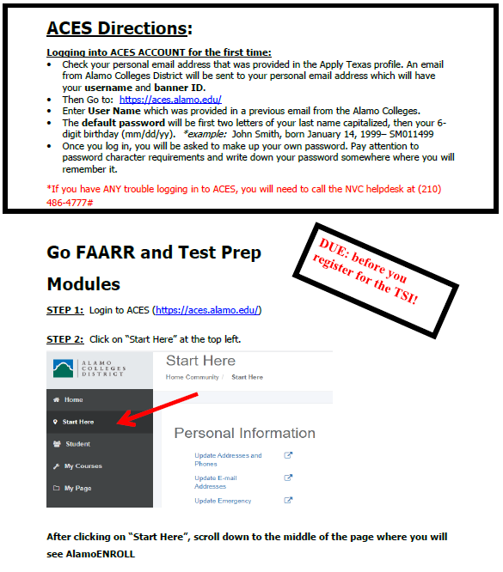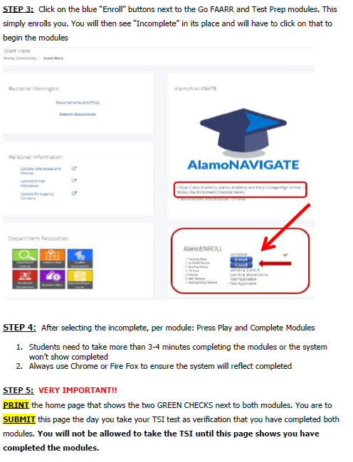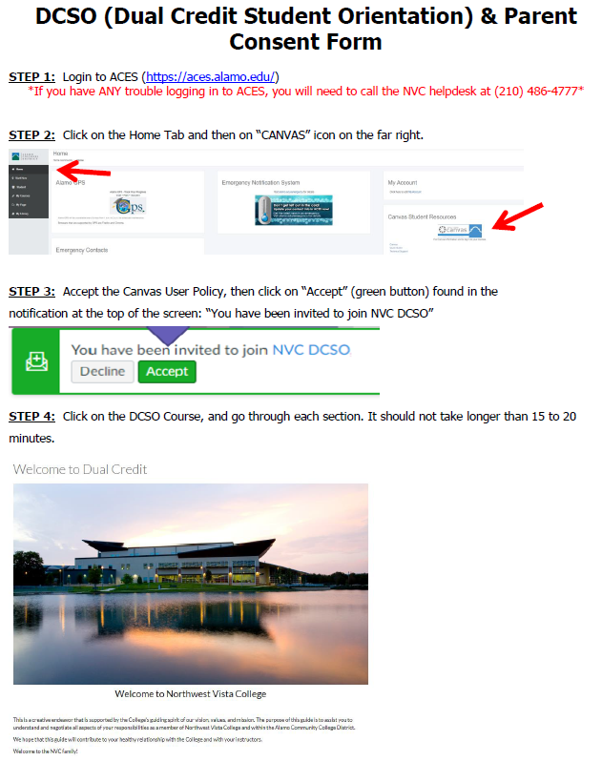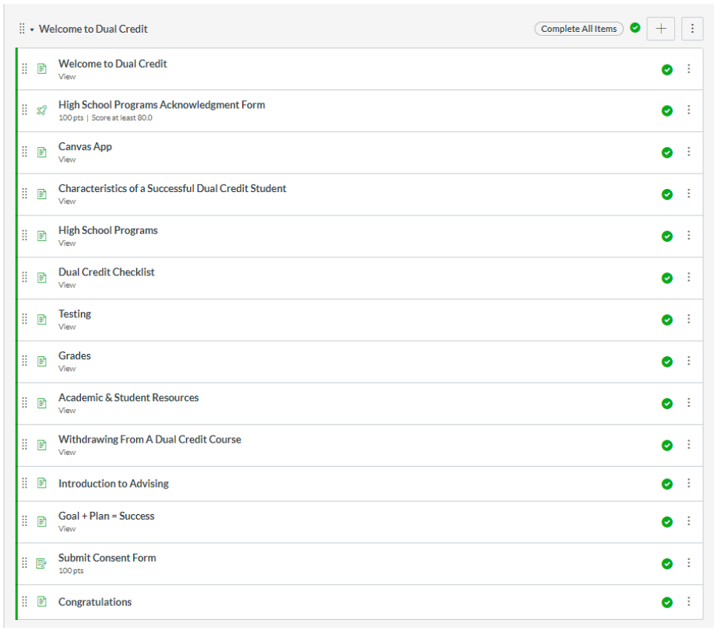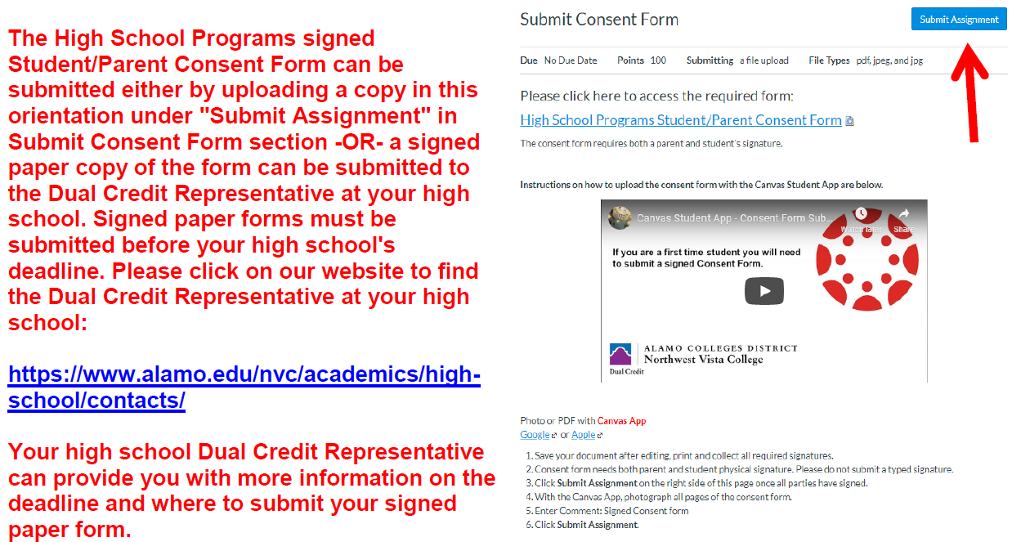
ASU Dual Credit

Sem | ASU Course | Sem | ASU Course
Fall | *Introduction to Art (ARTS 1301) | Spring | *Introduction to Music (MUSI 1306)
Fall | *Public Speaking (COMM 1315) | Spring | *Public Speaking (COMM 1315)
Fall | US History (HIST 1301) | Spring | US History (HIST 1302)
Fall | **College Algebra (MATH 1314) | Spring | **College Algebra (MATH 1314)
Fall | *General Physics (PHYS 1301/1101) | Spring | *General Physics II (PHYS 1302/1102)
Fall | *Fundamentals of Astronomy (PHYS 1303) | Spring | *Astronomy of the Solar System (PHYS 1304)
Fall | *American Government (POLS 2305) | Spring | *Texas Government (POLS 2306)
Fall | *General Psychology (PSY 2301) | Spring | *General Psychology (PSY 2301)
Fall | English IV (1401) | Spring | English IV (1402)
Fall | *Introduction to Brit Lit (ENGL 2321) | Spring | *Introduction to American Lit (ENGL 2326)
Fall | *English Comp (ENGL 1301) | Spring | *Writing Across the Curriculum (ENGL 1302)
Fall | *Prin. of Biology (1306) | Spring | *Prin. of Biology (1307)
*Online classes only ** Online or in person All courses subject to change

Steps to apply for ASU Dual Credit:
- Join Dual Credit Google Classroom
- Complete the ASU Dual Credit Application
- Have parents sign agreement form sent to their email address
- Request from registrar a High School Transcript to be sent to ASU
- Sign up for dual credit classes
UT OnRamps
~Classes offered: English 3, Physics, College Algebra, Pre Cal, Earth Wind and Fire, and US History
~No application process: just pick classes during course selection ~Fees will apply per course taken

